**Introduction to Computer Network EA3 Online Game**

team：14

team member：許心慈(b06502051,機械三),鐘民憲(b06901017,電機三)

**1. Introduction**

Online game is a video game which is played through the Internet. Typically, it runs on a client-server architecture with authoritative servers handling the game logic. When a player performs an action, the client sends a message to the server. The server processes the message and sends the new game state back to the client. The client then displays the new game state to the player and the process repeats.

With fast development of broadband access networks, both the revenue in online game industry and the popularity of gamers grow explosively. According to [1], online game revenue amounts to US$19,941m and the number of users reaches 827m this year(2019), which is incredible. Therefore, we are curious about how the Internet handles such gigantic data transfer, and also minimize the time latency. Another reason why we pick this topic is that we both used to be addicted to online games in our childhoods. This is a good chance to explore the secrets behind. Because of page limitation, we will mainly focus on time latency of online game and discuss some techniques to to improve players’ experience.

**2.Different Latency Sensitivity in Online Games**

Actually, not all aspects of player interactions are sensitive to latency as imagined. Generally, online games go through 4 phases:*setup*, *synchronization*, *play* and *transition*. Setup time is when a player hosting a game and waiting for others to join. After setup, many game states and parameter settings need to be synchronized between players. Afterwards, the game starts and most of communications and interactions happen in play phase. Within this phase, some games have transition phase where game information is loaded from disk to memory. As a result, the synchronization phase requires the highest bitrates in order to exchange data as fast as possible to proceed on to gameplay, and the play phase demands moderate bitrates with frequent exchanges of small network packets.

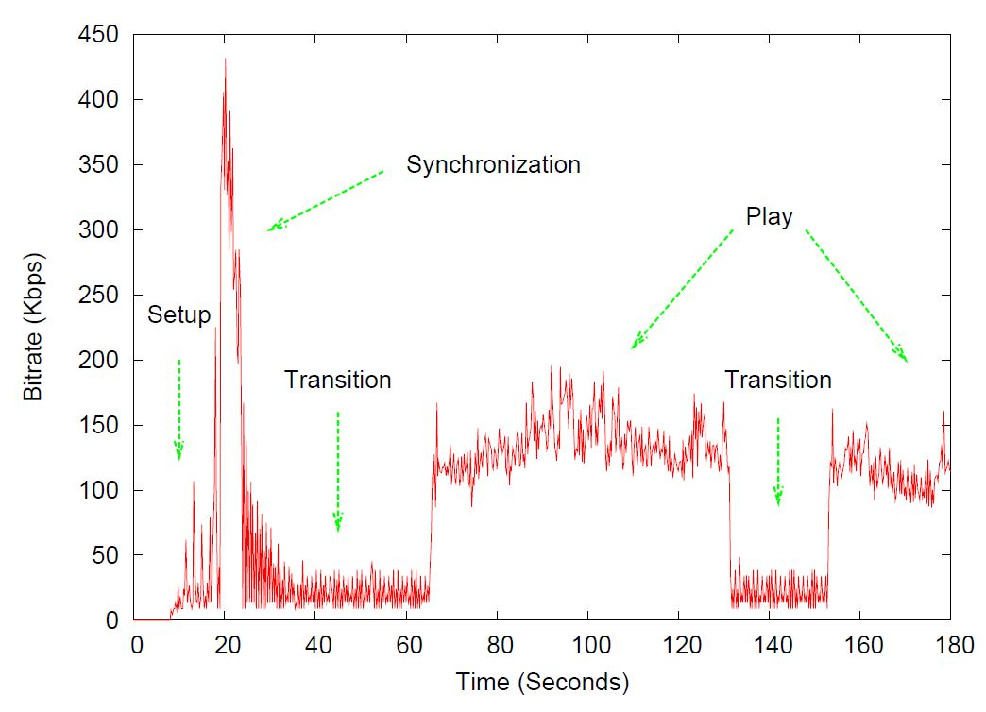

Although the bitrate demand in synchronization phase is the highest, players won’t feel the latency in this phase. However, delay effects players significantly during play phase. Thus, the latency in play phase is of most interest.

In play phase, not all player actions are equally tolerant to latency. They can be categorized based on the *precision* required to complete the action and the *deadline* by which the action must be completed. Actions with higher precision and tight deadlines are much sensitive to latency than those with lower precision and loose deadlines. For example, shooting a moving enemy in FPS tolerates less latency than migrating a troop in RTS.

**3. Latency Compensation Techniques**

In order to improve players’ experience, there are some latency compensation techniques being used in real life listed below:

**a.** **Prediction：**The technique of prediction can be catagorized as “Player Prediction” and “Opponent Prediction”.For*Player Prediction*, the client predicts the server's response, and allows the client to render player actions before getting the authoritative response from the server. As for Opponent Prediction, it works on basic physics. With the knowledge of last position of the opponent as well as the moving speed and direction, we can compute its current position. However, prediction sometimes causes inconsistencies between the state at the server and one at the client. But updating the differences between the states may impact user’s experience because the display is abruptly changed by rendering the correct scene over the predicted one.

**b. Data compression:**．***Lossless Compression.***Lossless data compression finds repeated patterns in the bits and compresses them into fewer bits. (ex. LZW algorithms)   
．***Delta Compression.*** Rather than sending complete state information of the world, only send what is changed from previous world.  
．***Others.*** Interest Management / Update Aggregation / Peer-to-Peer ...

**c. Time Warp:**

Time warp is a widely used time manipulation mechanism. It has a server to rollback a game to the time when a client command was input. Time warp requires the measurement of the latency to be accurate so that the game time can be rolled back exactly. With time warp, players can have their commands executed in proper time without worrying about latency.

**4.Conclusion**

Despite technology improvement, network delay(especially coast-to-coast delays) will always remain because of the speed of light in fiber. Latency in online game not only causes unfairness but also degrades players’ experience, which further decreases the revenue of the game company. Thus, latency problem is still a topic worth discussing nowadays. To deal with it, there are already many techniques being employed in network and game design. As mentioned above, we’ve discussed the techniques such as *prediction, data compression, and time manipulation.* Overall, there is no optimal solution and most of them are just a trade-off.

**5.Reference**

[1] Online game statistics

<https://www.statista.com/outlook/212/100/online-games/worldwide>

[2] Mark Claypool, “On Latency and Player Actions in Online Games(2006)”

[3] Grenville Armitage, “Networking and Online Games: Understanding and Engineering Multiplayer Internet Games”